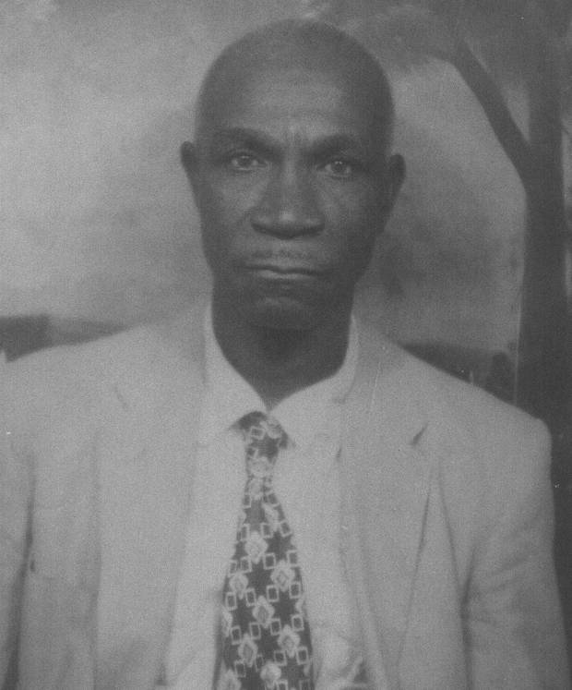
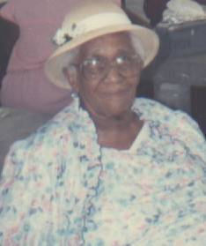
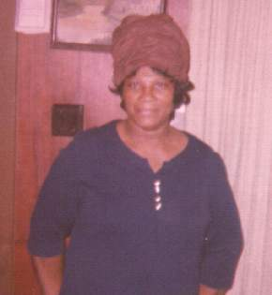
M
Aaron Davis-President
Stewart Merrell-Vice-Pres
Mary Etta Ford-Secretary
Barbara Davis-Asst Sec
Shanona Warthen-Treas

The re-union meeting for Sept. was held at the home of Stewart and Barbara Merrell, Saturday, October 4th at 6pm. The family members in attendance were, Aaron Davis, Stewart Merrell, Jessie Rene Davis, Clifford Merrell, Mary Etta Merrell, Barbara Davis, Barbara Merrell, Bob Kelsey, Steve Kelsey, Henry Kelsey, Darryl Fraley and Stewart Merrell II
The reading of the minutes from the previous meeting was read and the floor was now open for any old and new business. The old business was the discussion on weather the dinner was still on for December 3rd. To make sure there would be enough food, it was decided to sell tickets for five dollars for adults and free for children under 13 so no one would have to bring any food. Someone will be around asking you to buy your ticket.
The main discussion for new business was ways to raise money for the treasury. It was suggested that the committee raffle off a TV and some other item each month. It was also mentioned that each family should pay their $10 dues each month. Just keep in mind that you will not have to pay any addition money, just show up for the family re-union with your family.
It was also suggested that the committee find a way to invite the Pierce family to join the Merrell family re-union celebration in 2005. Addie Merrell have sisters out there the family knows nothing about and it would be nice to get to meet them and their families. Barbara Merrell volunteered to contact some of the Pierce family and see if it was possible for them to join us in 2005. She will report back to the Committee at the next meeting with any updates on the subject.
There was a short discussion on plans for a side trip sometimes next year to a place like Charleston, Savannah or Myrtle Beach for those that might want to get away for a few days. The Committee asked Bob Kelsey to check this out for them. He agreed and will get a few quoted on a few locations and get back to the Committee in a few months.
The financial report was read by Shonna Warthen, treasurer, and the meeting was adjourned. The next meeting will be held at the home of Jessie Rene Davis in Toomsboro, Ga.
The Merrell Update
October, 2004
Volume 2, Issue 1

Family Re-Union Meeting
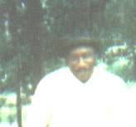
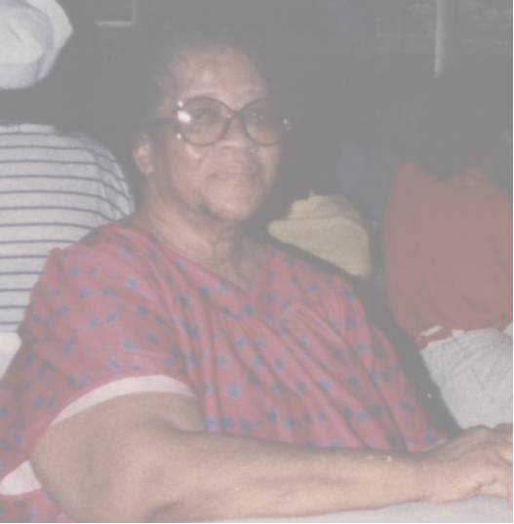
The family that prays together , stays together.

A fish fry was held following the meeting at the home of Stewart and Barbara Merrell. This event was sponsored by Bob Kelsey and with the co-operation of everyone in attendance, it was deemed a success. Each family brought a side dish and everyone just ate until they couldn’t easy anymore. This gave family members the opportunity to catch up on things going on within the family and to just socialize and enjoy each other’s company. It was suggested that we should have more social events like this in the future. If you have any suggestions or want to sponsor a social event, please contact Aaron Merrell, 478-933-3045 or Stewart Merrell, 478-552-1003 and they would gladly help make it happen. Most of the families live with a 30 miles radius of each other so let’s support any ideals that help to make the family closer and stronger.
If you have birthdays, anniversaries or any other events you want published in the newsletter, send an email to Bob Kelsey at bklesey2005@mindspring.com.

SOCIAL EVENTS AND ANNOUNCEMENTS
Don’t forget to visit the Family web page and catch up on some of the events and announcements you may have missed and that address is www.thefamilygatheringplace.com. It is hard to keep in updated without your inputs. If you have some pictures from past events, please send them to Bob Kelsey at 4524 Newby Drive, Unit H-7, Durham, NC 27704 and he will have them posted on the site. All the pictures from the re-union have not been posted but will very soon. If you see any mistakes on the site, let Bob know so they can be corrected right away..

Menu for the Christmas Dinner Dec 4th.

Fried and Bar-b-q chicken
Ham
Dressing
Turnips & green beans
Potato salad
Macaroni and cheese
Cake, pies and lemonade

THE FAMILY WEB PAGE

